**Modern College of Arts, Science and Commerce, Pune-05**

**Department of Statistics**

**M.Sc. II (Semester IV)**

**Date: Submission date:**

**Practical No.: 5(i)**

**Title:2k  Factorial Experiments, Analysis of single Replicate of 2k factorial experiment.**

______________________________________________________________________________________

Q.1 Four factors A, B, C and D each at two levels are to be compared. Only 8 of the possible 16 treatment combinations have been tried in CRD. The half replicate tried and associated observations are given below.

|  |  |  |  |  |  |  |  |  |
| --- | --- | --- | --- | --- | --- | --- | --- | --- |
| Treatment | bc | abcd | (1) | ad | bd | ab | cd | ac |
| Observation | 105 | 143 | 84 | 118 | 102 | 140 | 78 | 115 |

Analyse the data using an appropriate technique, what is the resolution of the design? Comment on the estimability of the main effects and two factor interactions, Plot and interpret main effects / interaction plots wherever appropriate.

**Design Summary**

|  |  |  |  |  |  |
| --- | --- | --- | --- | --- | --- |
| Factors: | 4 | Base Design: | 4, 8 | Resolution: | IV |
| Runs: | 8 | Replicates: | 1 | Fraction: | 1/2 |
| Blocks: | 1 | Center pts (total): | 0 |  |  |

Design Generators: D = ABC

**Alias Structure**

|  |
| --- |
| I + ABCD |
| A + BCD |
| B + ACD |
| C + ABD |
| D + ABC |
| AB + CD |
| AC + BD |
| AD + BC |

**Main effects are not estimable whereas interaction effect is estimable**.

**Coded Coefficients**

|  |  |  |  |  |  |  |
| --- | --- | --- | --- | --- | --- | --- |
| **Term** | **Effect** | **Coef** | **SE Coef** | **T-Value** | **P-Value** | **VIF** |
| Constant |  | 110.6 | * | * | * |  |
| A | 36.75 | 18.38 | * | * | * | 1.00 |
| B | 23.75 | 11.88 | * | * | * | 1.00 |
| C | -0.7500 | -0.3750 | * | * | * | 1.00 |
| D | -0.7500 | -0.3750 | * | * | * | 1.00 |
| A*B | 1.2500 | 0.6250 | * | * | * | 1.00 |
| A*C | 0.7500 | 0.3750 | * | * | * | 1.00 |
| A*D | 3.750 | 1.875 | * | * | * | 1.00 |

**Model Summary**

|  |  |  |  |
| --- | --- | --- | --- |
| **S** | **R-sq** | **R-sq(adj)** | **R-sq(pred)** |
| * | 100.00% | * | * |

**Analysis of Variance**

|  |  |  |  |  |  |
| --- | --- | --- | --- | --- | --- |
| **Source** | **DF** | **Adj SS** | **Adj MS** | **F-Value** | **P-Value** |
| Model | 7 | 3863.87 | 551.98 | * | * |
| Linear | 4 | 3831.50 | 957.87 | * | * |
| A | 1 | 2701.12 | 2701.12 | * | * |
| B | 1 | 1128.12 | 1128.12 | * | * |
| C | 1 | 1.12 | 1.12 | * | * |
| D | 1 | 1.13 | 1.13 | * | * |
| 2-Way Interactions | 3 | 32.37 | 10.79 | * | * |
| A*B | 1 | 3.13 | 3.13 | * | * |
| A*C | 1 | 1.12 | 1.12 | * | * |
| A*D | 1 | 28.12 | 28.12 | * | * |
| Error | 0 | * | * |  |  |
| Total | 7 | 3863.87 |  |  |  |

**Regression Equation in Uncoded Units**

|  |  |  |
| --- | --- | --- |
| y | = | 110.6 + 18.38 A + 11.88 B - 0.3750 C - 0.3750 D + 0.6250 A*B + 0.3750 A*C + 1.875 A*D |

**Alias Structure**

|  |  |  |
| --- | --- | --- |
| **Factor** | **Name** | |
| A | A | |
| B | B | |
| C | C | |
| D | D | |
| **Aliases** | |
| I + ABCD | |
| A + BCD | |
| B + ACD | |
| C + ABD | |
| D + ABC | |
| AB + CD | |
| AC + BD | |
| AD + BC | |

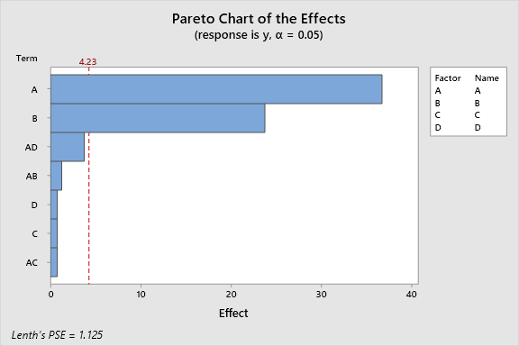

**Even though from Pareto chart it seems that factor A, factor B are significant in the model but P values and F values are not useful to draw conclusions from the ANOVA table.**

**Hence, we will remove those factors from the model which have effect value less than 1and reanalyse the design.**

**Factorial Regression: y versus A, B, C, D**

**Backward Elimination of Terms**

α to remove = 0.1  
The initial model was saturated. The stepwise procedure removed the following terms in order  
     to obtain sufficient degrees of freedom to begin: C, A*C

**Coded Coefficients**

|  |  |  |  |  |  |  |
| --- | --- | --- | --- | --- | --- | --- |
| **Term** | **Effect** | **Coef** | **SE Coef** | **T-Value** | **P-Value** | **VIF** |
| Constant |  | 110.625 | 0.473 | 233.76 | 0.000 |  |
| A | 36.750 | 18.375 | 0.473 | 38.83 | 0.000 | 1.00 |
| B | 23.750 | 11.875 | 0.473 | 25.09 | 0.000 | 1.00 |
| D | -0.750 | -0.375 | 0.473 | -0.79 | 0.486 | 1.00 |
| A*D | 3.750 | 1.875 | 0.473 | 3.96 | 0.029 | 1.00 |

**Model Summary**

|  |  |  |  |
| --- | --- | --- | --- |
| **S** | **R-sq** | **R-sq(adj)** | **R-sq(pred)** |
| 1.33853 | 99.86% | 99.68% | 99.01% |

**Analysis of Variance**

|  |  |  |  |  |  |
| --- | --- | --- | --- | --- | --- |
| **Source** | **DF** | **Adj SS** | **Adj MS** | **F-Value** | **P-Value** |
| Model | 4 | 3858.50 | 964.62 | 538.40 | 0.000 |
| Linear | 3 | 3830.37 | 1276.79 | 712.63 | 0.000 |
| A | 1 | 2701.12 | 2701.12 | 1507.60 | 0.000 |
| B | 1 | 1128.12 | 1128.12 | 629.65 | 0.000 |
| D | 1 | 1.13 | 1.13 | 0.63 | 0.486 |
| 2-Way Interactions | 1 | 28.12 | 28.12 | 15.70 | 0.029 |
| A*D | 1 | 28.12 | 28.12 | 15.70 | 0.029 |
| Error | 3 | 5.37 | 1.79 |  |  |
| Total | 7 | 3863.87 |  |  |  |

**Regression Equation in Uncoded Units**

|  |  |  |
| --- | --- | --- |
| y | = | 110.625 + 18.375 A + 11.875 B - 0.375 D + 1.875 A*D |

**Alias Structure**

|  |  |  |
| --- | --- | --- |
| **Factor** | **Name** | |
| A | A | |
| B | B | |
| C | C | |
| D | D | |
| **Aliases** | |
| I + ABCD | |
| A + BCD | |
| B + ACD | |
| D + ABC | |
| AD + BC | |

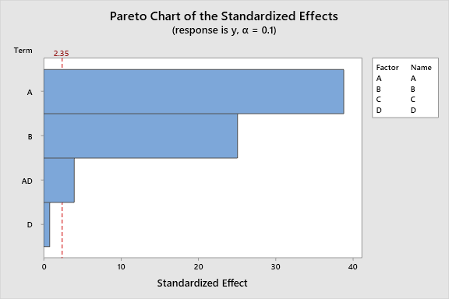

**From above pareto chart factor A, B and AD are significant to the model.**

**Factorial Plots for y**

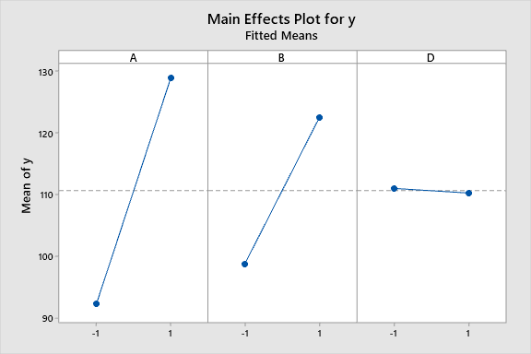

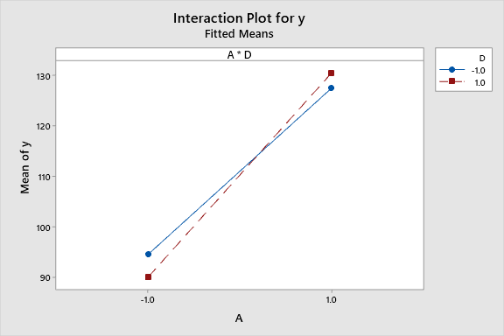

**From above two plots, it is clear that Main effect A and Main effect B, interaction effect AD are significant whereas Main effect D is not significant.**

Q.2 Five factors in a manufacturing process for an integrated circuit were investigated in a 25-1design with objective of improving the process yield. The five factors are

A: Aperture setting (Small, large)

B: Exposure time (20% below nomial)

C: Develop time (30s, 45 s)

D: Mask dimension (small, large)

E: Etch time (14.5 min, 15.5 min)

The data is given as follows:

|  |  |  |  |  |  |  |  |  |  |  |  |  |  |  |  |  |
| --- | --- | --- | --- | --- | --- | --- | --- | --- | --- | --- | --- | --- | --- | --- | --- | --- |
| Treatment combination | e | a | b | abe | c | ace | bce | abc | d | ade | bde | abd | cde | acd | bcd | abcde |
| Yield | 8 | 9 | 34 | 52 | 16 | 22 | 45 | 60 | 6 | 10 | 30 | 50 | 15 | 21 | 44 | 63 |

Analyze the data. Comment on the estimability of the main effects and two factor interactions. Plot and interpret main effects / interaction plots wherever appropriate.

**Fractional Factorial Design**

**Design Summary**

|  |  |  |  |  |  |
| --- | --- | --- | --- | --- | --- |
| Factors: | 5 | Base Design: | 5, 16 | Resolution: | V |
| Runs: | 16 | Replicates: | 1 | Fraction: | 1/2 |
| Blocks: | 1 | Center pts (total): | 0 |  |  |

Design Generators: E = ABCD

**Factorial Regression: y versus A, B, C, D, E**

**Coded Coefficients**

|  |  |  |  |  |  |  |
| --- | --- | --- | --- | --- | --- | --- |
| **Term** | **Effect** | **Coef** | **SE Coef** | **T-Value** | **P-Value** | **VIF** |
| Constant |  | 30.31 | * | * | * |  |
| A | 11.125 | 5.563 | * | * | * | 1.00 |
| B | 33.88 | 16.94 | * | * | * | 1.00 |
| C | 10.875 | 5.438 | * | * | * | 1.00 |
| D | -0.8750 | -0.4375 | * | * | * | 1.00 |
| E | 0.6250 | 0.3125 | * | * | * | 1.00 |
| A*B | 6.875 | 3.438 | * | * | * | 1.00 |
| A*C | 0.3750 | 0.1875 | * | * | * | 1.00 |
| A*D | 1.1250 | 0.5625 | * | * | * | 1.00 |
| A*E | 1.1250 | 0.5625 | * | * | * | 1.00 |
| B*C | 0.6250 | 0.3125 | * | * | * | 1.00 |
| B*D | -0.12500 | -0.06250 | * | * | * | 1.00 |
| B*E | -0.12500 | -0.06250 | * | * | * | 1.00 |
| C*D | 0.8750 | 0.4375 | * | * | * | 1.00 |
| C*E | 0.3750 | 0.1875 | * | * | * | 1.00 |
| D*E | -1.3750 | -0.6875 | * | * | * | 1.00 |

**Model Summary**

|  |  |  |  |
| --- | --- | --- | --- |
| **S** | **R-sq** | **R-sq(adj)** | **R-sq(pred)** |
| * | 100.00% | * | * |

**Analysis of Variance**

|  |  |  |  |  |  |
| --- | --- | --- | --- | --- | --- |
| **Source** | **DF** | **Adj SS** | **Adj MS** | **F-Value** | **P-Value** |
| Model | 15 | 5775.44 | 385.03 | * | * |
| Linear | 5 | 5562.81 | 1112.56 | * | * |
| A | 1 | 495.06 | 495.06 | * | * |
| B | 1 | 4590.06 | 4590.06 | * | * |
| C | 1 | 473.06 | 473.06 | * | * |
| D | 1 | 3.06 | 3.06 | * | * |
| E | 1 | 1.56 | 1.56 | * | * |
| 2-Way Interactions | 10 | 212.63 | 21.26 | * | * |
| A*B | 1 | 189.06 | 189.06 | * | * |
| A*C | 1 | 0.56 | 0.56 | * | * |
| A*D | 1 | 5.06 | 5.06 | * | * |
| A*E | 1 | 5.06 | 5.06 | * | * |
| B*C | 1 | 1.56 | 1.56 | * | * |
| B*D | 1 | 0.06 | 0.06 | * | * |
| B*E | 1 | 0.06 | 0.06 | * | * |
| C*D | 1 | 3.06 | 3.06 | * | * |
| C*E | 1 | 0.56 | 0.56 | * | * |
| D*E | 1 | 7.56 | 7.56 | * | * |
| Error | 0 | * | * |  |  |
| Total | 15 | 5775.44 |  |  |  |

**Regression Equation in Uncoded Units**

|  |  |  |
| --- | --- | --- |
| y | = | 30.31 + 5.563 A + 16.94 B + 5.438 C - 0.4375 D + 0.3125 E + 3.438 A*B + 0.1875 A*C + 0.5625 A*D + 0.5625 A*E + 0.3125 B*C - 0.06250 B*D - 0.06250 B*E + 0.4375 C*D + 0.1875 C*E - 0.6875 D*E |

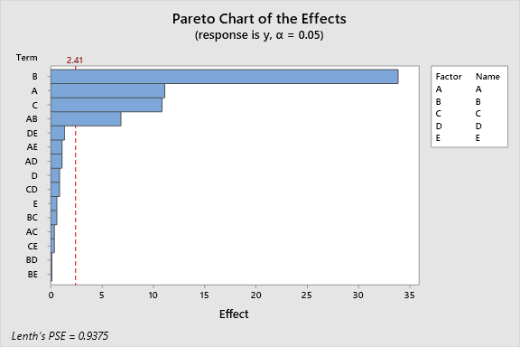

**Even though from Pareto chart it seems that factor A, factor B , factor C, interaction effect AB are significant in the model but P values and F values are not useful to draw conclusions from the ANOVA table.**

**Hence, we will remove those factors from the model which have effect value less than 1and reanalyse the design.**

**Factorial Regression: y versus A, B, C, D, E**

**Coded Coefficients**

|  |  |  |  |  |  |  |
| --- | --- | --- | --- | --- | --- | --- |
| **Term** | **Effect** | **Coef** | **SE Coef** | **T-Value** | **P-Value** | **VIF** |
| Constant |  | 30.313 | 0.140 | 216.90 | 0.000 |  |
| A | 11.125 | 5.563 | 0.140 | 39.80 | 0.000 | 1.00 |
| B | 33.875 | 16.938 | 0.140 | 121.19 | 0.000 | 1.00 |
| C | 10.875 | 5.438 | 0.140 | 38.91 | 0.000 | 1.00 |
| D | -0.875 | -0.438 | 0.140 | -3.13 | 0.035 | 1.00 |
| E | 0.625 | 0.312 | 0.140 | 2.24 | 0.089 | 1.00 |
| A*B | 6.875 | 3.438 | 0.140 | 24.60 | 0.000 | 1.00 |
| A*D | 1.125 | 0.562 | 0.140 | 4.02 | 0.016 | 1.00 |
| A*E | 1.125 | 0.563 | 0.140 | 4.02 | 0.016 | 1.00 |
| B*C | 0.625 | 0.312 | 0.140 | 2.24 | 0.089 | 1.00 |
| C*D | 0.875 | 0.437 | 0.140 | 3.13 | 0.035 | 1.00 |
| D*E | -1.375 | -0.688 | 0.140 | -4.92 | 0.008 | 1.00 |

**Model Summary**

|  |  |  |  |
| --- | --- | --- | --- |
| **S** | **R-sq** | **R-sq(adj)** | **R-sq(pred)** |
| 0.559017 | 99.98% | 99.92% | 99.65% |

**Analysis of Variance**

|  |  |  |  |  |  |
| --- | --- | --- | --- | --- | --- |
| **Source** | **DF** | **Adj SS** | **Adj MS** | **F-Value** | **P-Value** |
| Model | 11 | 5774.19 | 524.93 | 1679.76 | 0.000 |
| Linear | 5 | 5562.81 | 1112.56 | 3560.20 | 0.000 |
| A | 1 | 495.06 | 495.06 | 1584.20 | 0.000 |
| B | 1 | 4590.06 | 4590.06 | 14688.20 | 0.000 |
| C | 1 | 473.06 | 473.06 | 1513.80 | 0.000 |
| D | 1 | 3.06 | 3.06 | 9.80 | 0.035 |
| E | 1 | 1.56 | 1.56 | 5.00 | 0.089 |
| 2-Way Interactions | 6 | 211.38 | 35.23 | 112.73 | 0.000 |
| A*B | 1 | 189.06 | 189.06 | 605.00 | 0.000 |
| A*D | 1 | 5.06 | 5.06 | 16.20 | 0.016 |
| A*E | 1 | 5.06 | 5.06 | 16.20 | 0.016 |
| B*C | 1 | 1.56 | 1.56 | 5.00 | 0.089 |
| C*D | 1 | 3.06 | 3.06 | 9.80 | 0.035 |
| D*E | 1 | 7.56 | 7.56 | 24.20 | 0.008 |
| Error | 4 | 1.25 | 0.31 |  |  |
| Total | 15 | 5775.44 |  |  |  |

**Regression Equation in Uncoded Units**

|  |  |  |
| --- | --- | --- |
| y | = | 30.313 + 5.563 A + 16.938 B + 5.438 C - 0.438 D + 0.312 E + 3.438 A*B + 0.562 A*D + 0.563 A*E + 0.312 B*C + 0.437 C*D - 0.688 D*E |

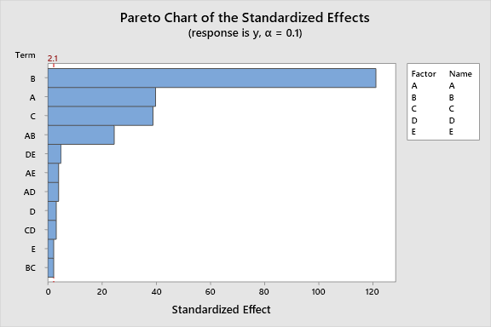

**Factors above mentioned are all significant for the model.**

**Factorial Plots for y**

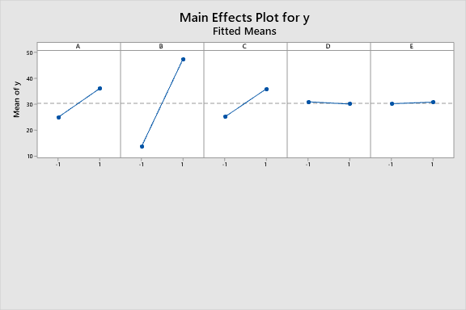

**Main effect A, B and C are significant whereas D and E are not significant.**

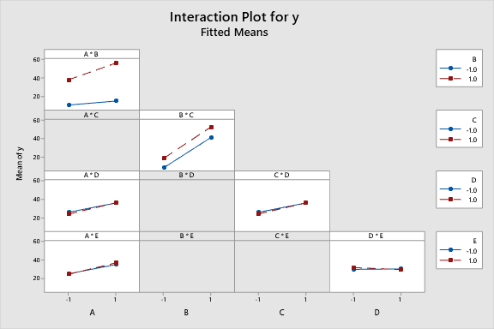

**Interaction effect AD, AE, CD and DE are significant all other interaction effects are not significant.**

Q.3 The following data represents a single replicate of a 25 design used in an experiment to study the tensile strength of rubber. The factors are mix (A), time (B), laboratory (C) temperature (D) and pressure (E). Suppose the only a quarter fraction of the design could be run. Construct the design using a set of suitable generators and analyze the data.

|  |  |  |  |  |  |  |  |
| --- | --- | --- | --- | --- | --- | --- | --- |
| (1) | 15 | d | 10 | e | 8 | de | 10 |
| a | 29 | ad | 31 | ac | 32 | ade | 35 |
| b | 44 | bd | 40 | be | 45 | bde | 50 |
| ab | 65 | abd | 71 | abe | 72 | abde | 75 |
| c | 16 | cd | 18 | cde | 25 | ae | 20 |
| acd | 21 | ace | 22 | acde | 30 | bc | 40 |
| bcd | 44 | bce | 35 | bcde | 44 | abc | 60 |
| abcd | 70 | abce | 65 | abcde | 75 |  |  |

Analyze the data using an appropriate technique. What is the resolution of the design? Comment on the estimability of the main effects and two factor interactions. Plot and interpret main effects / interaction plots wherever appropriate.

**Fractional Factorial Design**

**Design Summary**

|  |  |  |  |  |  |
| --- | --- | --- | --- | --- | --- |
| Factors: | 5 | Base Design: | 5, 8 | Resolution with blocks: | II |
| Runs: | 8 | Replicates: | 1 | Fraction: | 1/4 |
| Blocks: | 4 | Center pts (total): | 0 |  |  |

Design Generators: D = AB, E = AC

Block Generators: ABC, ABCD

**Factorial Regression: y versus Blocks, A, B, C, D, E**

**Coded Coefficients**

|  |  |  |  |  |  |  |
| --- | --- | --- | --- | --- | --- | --- |
| **Term** | **Effect** | **Coef** | **SE Coef** | **T-Value** | **P-Value** | **VIF** |
| Constant |  | 38.75 | * | * | * |  |
| Blocks |  |  |  |  |  |  |
| 1 |  | 1.750 | * | * | * | 1.50 |
| 2 |  | -1.750 | * | * | * | 1.50 |
| 3 |  | -7.750 | * | * | * | 1.50 |
| A | 21.00 | 10.50 | * | * | * | 1.00 |
| B | 38.00 | 19.00 | * | * | * | 1.00 |
| E | -1.5000 | -0.7500 | * | * | * | 1.00 |
| B*C | -0.5000 | -0.2500 | * | * | * | 1.00 |

**Model Summary**

|  |  |  |  |
| --- | --- | --- | --- |
| **S** | **R-sq** | **R-sq(adj)** | **R-sq(pred)** |
| * | 100.00% | * | * |

**Analysis of Variance**

|  |  |  |  |  |  |
| --- | --- | --- | --- | --- | --- |
| **Source** | **DF** | **Adj SS** | **Adj MS** | **F-Value** | **P-Value** |
| Model | 7 | 4027.50 | 575.36 | * | * |
| Blocks | 3 | 252.50 | 84.17 | * | * |
| Linear | 3 | 3774.50 | 1258.17 | * | * |
| A | 1 | 882.00 | 882.00 | * | * |
| B | 1 | 2888.00 | 2888.00 | * | * |
| E | 1 | 4.50 | 4.50 | * | * |
| 2-Way Interactions | 1 | 0.50 | 0.50 | * | * |
| B*C | 1 | 0.50 | 0.50 | * | * |
| Error | 0 | * | * |  |  |
| Total | 7 | 4027.50 |  |  |  |

**Regression Equation in Coded Units**

|  |  |  |
| --- | --- | --- |
| y | = | 38.75 + 10.50 A + 19.00 B - 0.7500 E - 0.2500 B*C |

**Alias Structure**

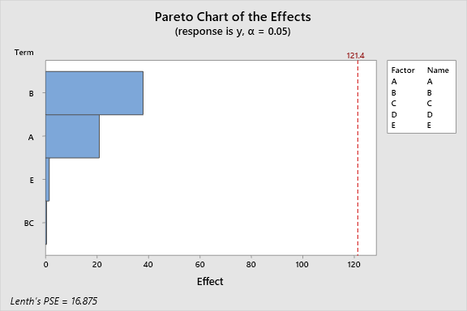

From above pareto chart not a single main effect or interaction effect is significant also F value and P values are undefined hence we need to reanalyze the design.

**Factorial Regression: y versus Blocks, A, B, C, D, E**

**Coded Coefficients**

|  |  |  |  |  |  |  |
| --- | --- | --- | --- | --- | --- | --- |
| **Term** | **Effect** | **Coef** | **SE Coef** | **T-Value** | **P-Value** | **VIF** |
| Constant |  | 38.750 | 0.559 | 69.32 | 0.000 |  |
| Blocks |  |  |  |  |  |  |
| 1 |  | 1.750 | 0.968 | 1.81 | 0.212 | 1.50 |
| 2 |  | -1.750 | 0.968 | -1.81 | 0.212 | 1.50 |
| 3 |  | -7.750 | 0.968 | -8.00 | 0.015 | 1.50 |
| A | 21.000 | 10.500 | 0.559 | 18.78 | 0.003 | 1.00 |
| B | 38.000 | 19.000 | 0.559 | 33.99 | 0.001 | 1.00 |

**Model Summary**

|  |  |  |  |
| --- | --- | --- | --- |
| **S** | **R-sq** | **R-sq(adj)** | **R-sq(pred)** |
| 1.58114 | 99.88% | 99.57% | 98.01% |

**Analysis of Variance**

|  |  |  |  |  |  |
| --- | --- | --- | --- | --- | --- |
| **Source** | **DF** | **Adj SS** | **Adj MS** | **F-Value** | **P-Value** |
| Model | 5 | 4022.50 | 804.50 | 321.80 | 0.003 |
| Blocks | 3 | 252.50 | 84.17 | 33.67 | 0.029 |
| Linear | 2 | 3770.00 | 1885.00 | 754.00 | 0.001 |
| A | 1 | 882.00 | 882.00 | 352.80 | 0.003 |
| B | 1 | 2888.00 | 2888.00 | 1155.20 | 0.001 |
| Error | 2 | 5.00 | 2.50 |  |  |
| Total | 7 | 4027.50 |  |  |  |

**Regression Equation in Uncoded Units**

|  |  |  |
| --- | --- | --- |
| y | = | 38.750 + 10.500 A + 19.000 B |

**Alias Structure**

|  |  |
| --- | --- |
| **Factor** | **Name** |
| A | A |
| B | B |
| C | C |
| D | D |
| E | E |
| **Aliases** | | |
| I + ABD + ACE + BCDE | | |
| Block 1 - C + D + AB - AE - BE - CD - ABC - ADE + BCE - BDE - ABCD + ACDE | | |
| Block 2 - C - D - AB - AE + BE + CD + ABC + ADE - BCE - BDE - ABCD - ACDE | | |
| Block 3 + C - D - AB + AE - BE - CD - ABC - ADE - BCE + BDE + ABCD - ACDE | | |
| A + BD + CE + ABCDE | | |
| B + AD + CDE + ABCE | | |

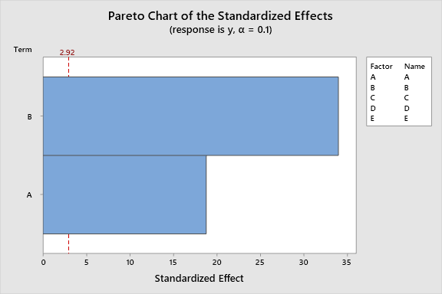

Main effect A and B are significant for the model.

**Factorial Plots for y**

* NOTE * There are no valid interactions to plot.

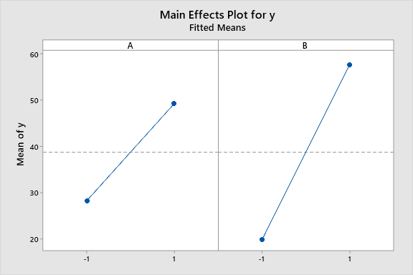

A and B main effects are significant.